

**PES UNIVERSITY**

**(Established under Karnataka Act No. 16 of 2013)**

**100-ft Ring Road, Bengaluru – 560 085, Karnataka, India**

**UE20EC352-Machine Learning and Applications**

***Report on***

**“**A MACHINE LEARNING MODEL FOR WEATHER FORECASTING**”**

*Submitted by*

KRITHIKA N (PES1UG20EC099)

N C KEERTHANA (PES1UG20EC116)

**JAN - MAY 2023**

Course Instructor: Vanamala HR Ma’am

Index

1. Introduction
2. Objective
3. Methodology & Algorithm
4. Tools Used
5. Implementation
6. Results
7. Conclusion
8. References

Introduction

Weather prediction is the task of predicting the atmosphere at a future time and a given area. This has been done through physical equations in the early days in which the atmosphere is considered fluid. The current state of the environment is inspected, and the future state is predicted by solving those equations numerically, but we cannot determine very accurate weather for more than 10 days and this can be improved with the help of science and technology.

Machine learning can be used to process immediate comparisons between historical weather forecasts and observations. With the use of machine learning, weather models can better account for prediction inaccuracies, such as overestimated rainfall, and produce more accurate predictions. Temperature prediction is of major importance in a large number of applications, including climate-related studies, energy, agricultural, medical, or etc.

Machine learning is relatively robust to perturbations and does not need any other physical variables for prediction. Therefore, machine learning is a much better opportunity in the evolution of weather forecasting. Before the advancement of Technology, weather forecasting was a hard nut to crack. Weather forecasters relied upon satellites, data model’s atmospheric conditions with less accuracy. Weather prediction and analysis have vastly increased in terms of accuracy and predictability with the use of the Internet of Things, for the last 40 years. With the advancement of Data Science, Artificial Intelligence, Scientists now do weather forecasting with high accuracy and predictability.

**Objective:**

Purpose of this project is to predict the temperature using different algorithms like linear regression and Decision tree regression. The output value should be numerically based on multiple extra factors like maximum temperature, minimum temperature, cloud cover, humidity, and sun hours in a day, precipitation, pressure and wind speed.

**Methodology & Algorithm**

* The dataset utilized in this arrangement has been gathered from Kaggle which is “Historical Weather Data for Indian Cities” from which we have chosen the data for “Kanpur City”. The dataset was created by keeping in mind the necessity of such historical weather data in the community. The datasets for the top 8 Indian cities as per the population. The datasets contain hourly weather data from 01-01-2009 to 01-01-2020. The data of each city is for more than 10 years. This data can be used to visualize the change in data due to global warming or can be used to predict the weather for upcoming days, weeks, months, seasons, etc.
* In this project, we are concentrating on the temperature prediction of Kanpur city with the help of various machine learning algorithms and various regressions. By applying various regressions on the historical weather dataset of Kanpur city we are predicting the temperature like first we are applying Multiple Linear regression, and then Decision Tree regression.
* In the end we compare both the type of regressions and can conclusively define the better regression method.

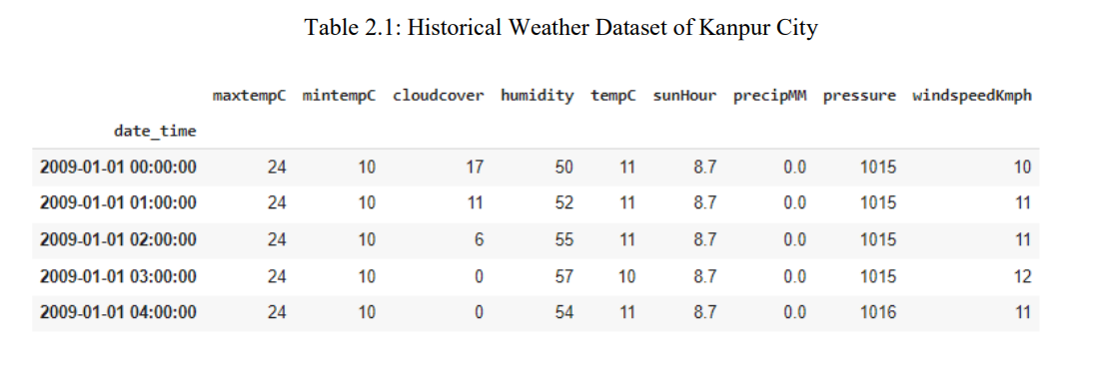

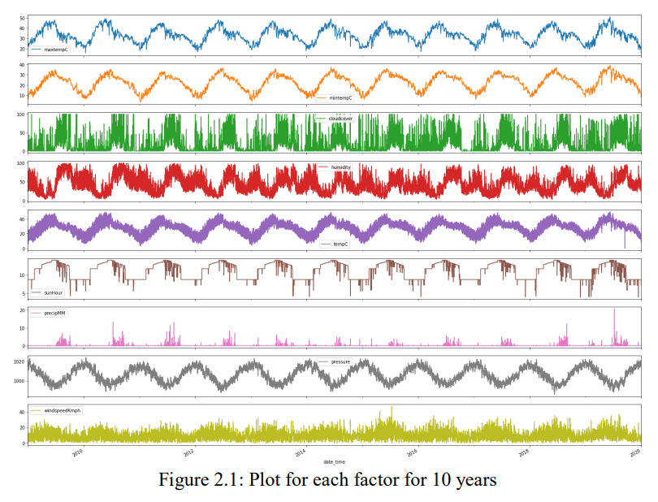

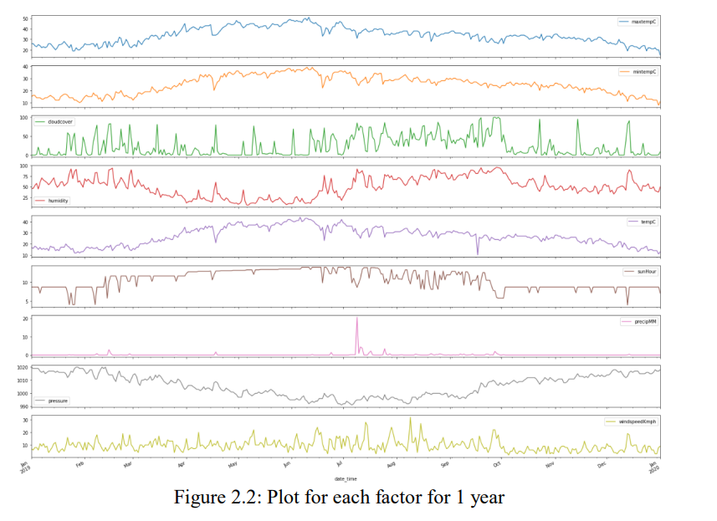

**Tools Used:**

1. Kaggle

2. Google colab

**Implementation:**

1. The record has just been separated into a train set and a test set. Each information has just been labeled.
2. First, we take the trainset organizer. We will train our model with the help of histograms and plots. The feature so extracted is stored in a histogram. This process is done for every data in the train set.
3. Now we will build the model of our classifiers. The classifiers which we will take into account are Linear Regression and Decision Tree Regression. With the help of our histogram, we will train our model.
4. Once the training is complete, we will take the test set. Now for each data variable of the test set, we will extract the features using feature extraction techniques and then compare its values with the values present in the histogram formed by the train set.
5. The output is then predicted for each test day. Now in order to calculate accuracy, we will compare the predicted value with the labeled value.
6. Once the predicted value of both the methods are obtained, the models are compared in order to decide the better one.

**Results:**

The results of the implementation of the project are demonstrated below.

**Multiple Linear Regression:**

This regression model has high mean absolute error, hence turned out to be the least accurate model. Given below is a snapshot of the actual result from the project implementation of multiple linear regression.

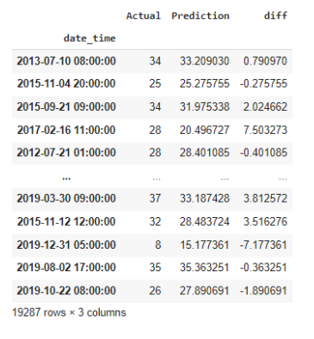

**Decision Tree Regression:**

This regression model has medium mean absolute error, hence turned out to be the little accurate model. Given below is a snapshot of the actual result from the project implementation of multiple linear regression.

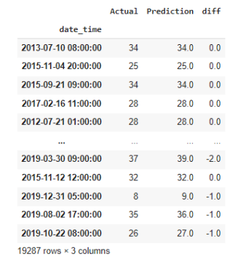

**Conclusion:**

1. In conclusion, we have successfully implemented a weather predicting machine learning model that can predict the weather with higher accuracy.
2. Then we compared the two models and found that decision tree regression is a more flexible model. The tree structure allows for complex interactions between the independent variables, which can be difficult to capture with linear regression.
3. In summary, our weather predicting model with Decision tree regression achieved a mean absolute error of 0.56 whereas our Linear regression achieved a mean absolute error of 1.2.

**References:**

1. <https://www.kaggle.com/datasets/hiteshsoneji/historical-weather-data-for-indian-cities>
2. https://towardsdatascience.com/weather-forecasting-with-machine-learning-using-python-55e90c346647